Experiment 7
Name: Maithili Sawant
Roll no: 33
Class: SE3

Books.xml
<?xml version="1.0" encoding="UTF-8"?>
<?xml-stylesheet type="text/xsl" href="books.xsl"?>
<bookstore>
<book>
<title>The Pragmatic Programmer</title>
<author>David Thomas &amp; Andrew Hunt</author>
<price currency="Rs">49.99</price>
</book>
<book>
<title>Clean Code</title>
<author>Robert C. Martin</author>
<price currency="Rs">54.99</price>
</book>
<book>
<title>You Don't Know JS</title>
<author>Kyle Simpson</author>
<price currency="Rs">39.99</price>
</book>
<book>
<title>Introduction to Algorithms</title>
<author>Cormen, Leiserson, Rivest, Stein</author>
<price currency="Rs">89.99</price>
</book>
<book>
<title>Design Patterns</title>
<author>Erich Gamma et al.</author>
<price currency="Rs">59.99</price>
</book>
</bookstore>

Books.xsl
<?xml version="1.0" encoding="UTF-8"?>
<xsl:stylesheet version="1.0" xmlns:xsl="http://www.w3.org/1999/XSL/Transform">
<xsl:output method="html" indent="yes" encoding="UTF-8" doctype-public="-//W3C//DTD
HTML 4.01 Transitional//EN"/>
<!-- Root template: create HTML structure -->
<xsl:template match="/">
<html>
<head>
<title>Bookstore Catalog</title>

<style>
body {
font-family: 'Segoe UI', Tahoma, Geneva, Verdana, sans-serif;
background: #f5f7fa;
margin: 2rem;
display: flex;
justify-content: center;
}
.container {
max-width: 900px;
background: white;
border-radius: 1rem;
box-shadow: 0 10px 25px rgba(0,0,0,0.1);
overflow: hidden;
padding: 1rem 1.5rem 2rem 1.5rem;
}
h1 {
color: #2c3e50;
border-left: 6px solid #3498db;
padding-left: 1rem;
margin-top: 0;
}
table {
width: 100%;
border-collapse: collapse;
margin-top: 1.5rem;
font-size: 0.95rem;
}
th {
background-color: #2c3e50;
color: white;
padding: 12px 8px;
text-align: left;
font-weight: 600;
}
td {
padding: 10px 8px;
border-bottom: 1px solid #e2e8f0;
}
tr:hover td {
background-color: #f1f9ff;
}

.price {
font-weight: bold;
color: #27ae60;
}
.footer {
margin-top: 1.5rem;
font-size: 0.8rem;
color: #7f8c8d;
text-align: center;
border-top: 1px solid #e2e8f0;
padding-top: 1rem;
}
</style>
</head>
<body>
<div class="container">
<h1>📚 Book Collection</h1>
<table>
<thead>
<tr>
<th>Title</th>
<th>Author(s)</th>
<th>Price</th>
</tr>
</thead>
<tbody>
<!-- Apply template for each book -->
<xsl:apply-templates select="bookstore/book"/>
</tbody>
</table>
<div class="footer">
Total books: <xsl:value-of select="count(bookstore/book)"/>
</div>
</div>
</body>
</html>
</xsl:template>
<!-- Template for one book row -->
<xsl:template match="book">
<tr>
<td><xsl:value-of select="title"/></td>
<td><xsl:value-of select="author"/></td>
<td class="price">
&#8377;<xsl:value-of select="price"/>
<xsl:if test="price/@INR">
<span style="font-size:0.7rem;">
(<xsl:value-of select="price/@INR"/>)
</span>
</xsl:if>
</td>
</tr>
</xsl:template>
</xsl:stylesheet>
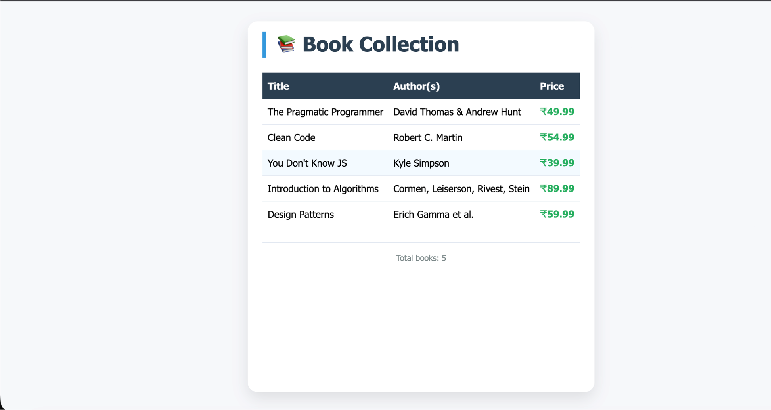

Output

